Temasek Polytechnic
School of Informatics and IT

Diploma in Information Technology (IT)

Software Requirement Specifications (SRS)

Project Particulars

Tutor | Ms Ho Li Chin
Class | P01
Project Title | Delonix Regia Hotel Management System

Project Team’s Particulars

Matric Number | Student Name
1405643F | Raymond How
1400465I | Yan Jia Chen
1401314H | Siti Nadirah

Revision History

Date | Version | Description | Author
21/05/2016 | 1.0 | First Draft | Raymond
27/05/2016 | 1.1 | Compiled Final | Raymond

Table of Contents

1. DISTRIBUTION OF WORKLOAD 4
2. OVERVIEW OF REQUIREMENTS 5
2.1 System Functions 5
2.2 User Characteristics 7
2.3 General Constraints 7
2.4 Functional Requirements 7
2.5 Data Requirements 8
2.6 User Interface Requirements 10
2.7 Interface with Other Systems 14
2.8 Assumptions 14
3 OPERATIONAL AND QUALITY REQUIREMENTS 14
3.1 Operating Environment 14
3.2 Development Constraints 14
3.3 Performance 14
3.4 Availability 15
3.5 Security and Access Control Requirements 15
4 SPECIAL REQUIREMENTS 17
5 REFERENCES 17

DISTRIBUTION OF WORKLOAD

Requirement Gathering | Members
System functions, data requirement and functional requirement of Room management module. Operating environment, user characteristics, special requirements, General Constraint, | Raymond
System functions, data requirement and functional requirement of Housekeeping and staff management module. Performance, Security and Access Control, Availability | Siti Nadirah
System functions, data requirement and functional requirement of Reporting module. Assumptions, Development Constraint, user interface requirement and interface with other system | Yan Jia Chen

OVERVIEW OF REQUIREMENTS

System Functions

Room Management

Room status

This function allows the users to view the status of a particular room. For example, the user is able to see whether room 88 is occupied or available or is vacant and schedule for cleaning. The user is also able to see the guest details that is occupying the room. The user is also able to assign a room that is available to the guest.

Reservation

This function allows the users to add/create new hotel room reservation. If a guest call in and wanted to book a room, the user is able to use the system to create a new reservation. If a guest call in to change his/her reservation details, the user is able to modify existing reservation. If a user wanted to cancel his/her reservation, the user is able to cancel/delete an existing reservation.

Payment

This function allows the user to generate a payment invoice of a guest. The user is able to view the payment details of the guest such as the total charges and the credit card details of the guest.

Housekeeping and Staff Management Module

Assign housekeeping duties

This function allows the manager to assign housekeeping duties to the staff. The manager can also see which duties and staff has been assigned to. The duties are general maintenance, room maintenance, estate maintenance and security.

View staff records

This function allows the manager to view the personal records of the staff such as name, date of birth, address, contact number and type of duties that has been assigned to

Reporting Module

Room status Report

This function allows the manager to view the status of all the rooms whether is it occupied, vacant or vacant but scheduled for maintenance or cleaning.

Guest List (By Room)

This allow the Admin and Manager to view the guest staying which particular room and the number of people staying together such as the number of adult and the number of children.

Guest List (By Date)

This function allows the manager to view all the guest staying at the hotels rooms if he/she select a date

Room occupancy

With this function Admin and Manager able to view the occupy room and number of days occupy. They could make a further planning when that an event occurs and many room needed be book.

User Account

Administrator could create and delete the user account. Example that is a new staff joint the hotel, Administrator will able to create the user account for the new staff for he or she is able to access to system

User Characteristics

Receptionist

The receptionist will have access to the full features about the room management module and certain reporting module features. The receptionist will be at the front desk to check-in and check-out the hotel guest.

Management

The management will have access to the full features of the 3 modules (Room Management, Housekeeping and Staff management, Reporting)

Administrator

The administrator will have access to the full features of the 3 modules (Room Management, Housekeeping and Staff management, Reporting) and an additional user account manager control feature that allows the administrator to create new user account or delete existing user account.

General Constraints
The system that the hotel is using is an old Pentium 4 windows XP computer. As technology advances, the operating system has outdated and not able to support the system that has been developed. The hotel will need to upgrade the computer when the system is deployed.

Functional Requirements

Guest details modification

This system should allow the user to modify the guest details any time. (eg. There is additional guest staying in the room)

Print preview

This function allows the user to preview the report before it is printed
Housekeeping report
The system enables user to generate housekeeping schedule based on daily, weekly and monthly basis.

Types of duties

This system enables the user to make changes to the types of duties which the staffs are allocated to. This is especially because there are four types of duties – general maintenance, estate maintenance, room maintenance and security. Thus, each staff can be allocated to the different duties more than once.

Room Occupancy Report
This function allows the manager to generate statistic report based on the room occupancy on a daily, weekly and monthly basis. This report should only be available to the manager and administrator.

Data Requirements

Room availability

The system should capture number of adult/children staying in the room of the guest and guest details such as the first name and last name, contact details, email address and home address. The home address will contain street name, block, unit number and the country of residence. It should also capture the payment details of the guest such as the type of payment and the details of the guest credit card such as the credit card number, card holder name and the expiration date. The system is also able to capture the check-in and check-out date and time of the guest and also any additional remarks that the guest will make such as a special request.

 | Data Type
GuestID | int
FirstName | varchar(30)
LastName | varchar(30)
NoOfAdults | Int (4)
NoOfChildrens | Int (4)
Contact | Int (15)
Email address | Varchar
Street Name | Varchar
Block | Int
Unit number | Int
Country | Varchar
Credit Card Number | Int (16)
Card Type | Varchar (6)
Card Holder Name | Varchar (30)
Expiry Date | date
Check in date/time | Datetime
Check out date/time | Datetime
Remarks | Varchar (100)

Housekeeping and staff management
This module is accessible to both the administrators and managers only; and it generates the personnel records and duty rosters of the staff based on daily, weekly and monthly basis.

The housekeeping management function should consist of (1) records of the staffs’ name, which consists of the first and last name. (2) Their date of birth, which consists of the day, month and year. The staffs’ (3) bank account number, their (4) home address, which consists of the street name, block number, door number, as well as the postal code. Their (5) phone number and the (6) types of duties which the staffs are allocated to, which consists of room maintenance, general maintenance, estate maintenance and security. And these set of data are only available to the managers and administrators.

staff_ID (Primary Key) | varchar 15
first_name | varchar 40
last_name | varchar 40
date_of_birth | date
bank_acc_no | varchar 20
home_address | varchar 60
phone_no | int 25
types_of_duties | varchar 40

Staff name
This function allows Mr. Wang to identify his staff if he ever wishes to know the name of the staff for some reference. For example, Mr. Wang could refer to this if he wishes to know which of this staffs did a particular duty during a certain time. This would make it easier for Mr. Wang to identify his staffs of the number of staffs he has. Also, it will make it clear of the duties which each staff has worked on during the day, week and month.

Date of birth
This function allows the users to see the date of birth of each staff. The date of birth of the staff is needed as part of the necessary information when the staffs applied for the job. This is to ensure that every staff is of a legal age to be working.

Bank account number
This function enables users to be able to see the staffs’ bank account numbers. It is important as it is known to be a necessary information whenever the staffs first applied for the job. This is because, their bank account numbers are needed in order for Mr. Wang to bank in their monthly salaries.

Home address
This function allows the users to see the staff’s home address, which includes the block, street name, postal code and door number. It is essential because it is part of the staffs’ particulars; and Mr. Wang would be able to refer to it if necessary. For example, if there is any incident whereby a mail or letter has to be sent to the staff, then this function will be useful.

Phone number
This function enables users to see the staffs’ phone numbers. This is a very useful function, because it is the most needed information for communication between the company and the staffs. For example, if Mr. Wang wishes to contact one of his staffs to convey an important message urgently, then this function is used.

Types of duties
This function displays the types of duties which the staffs are allocated to. There are four types of duties and they are (1) general maintenance, (2) room maintenance, (3) estate maintenance and (4) security.

User Interface Requirements

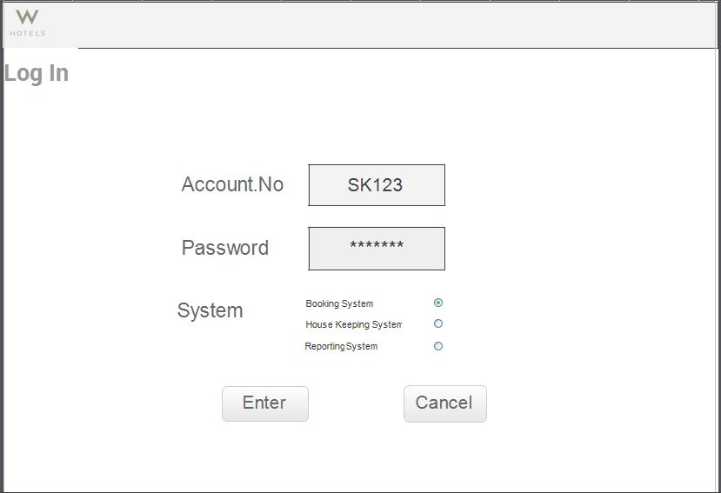
- Log In- will be the page where the first screen seems by user no matter the admin or the staff need to log in before using.

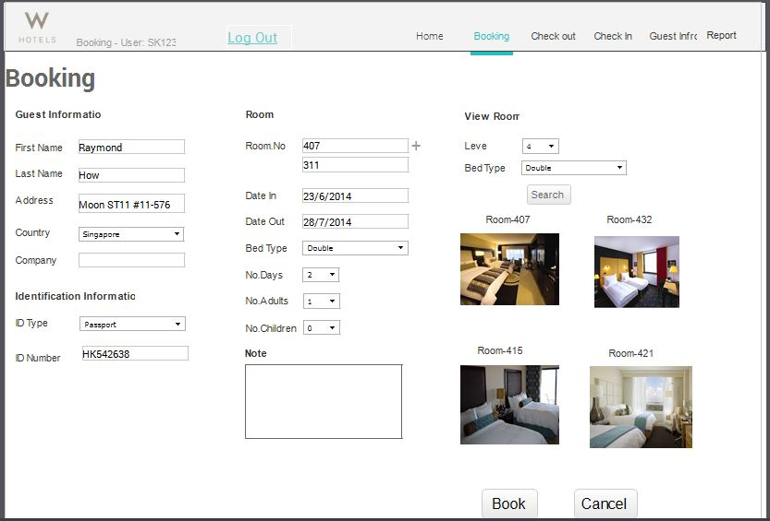
- Booking- Guest able to view and select the room available, at the same time fill in personal detail.

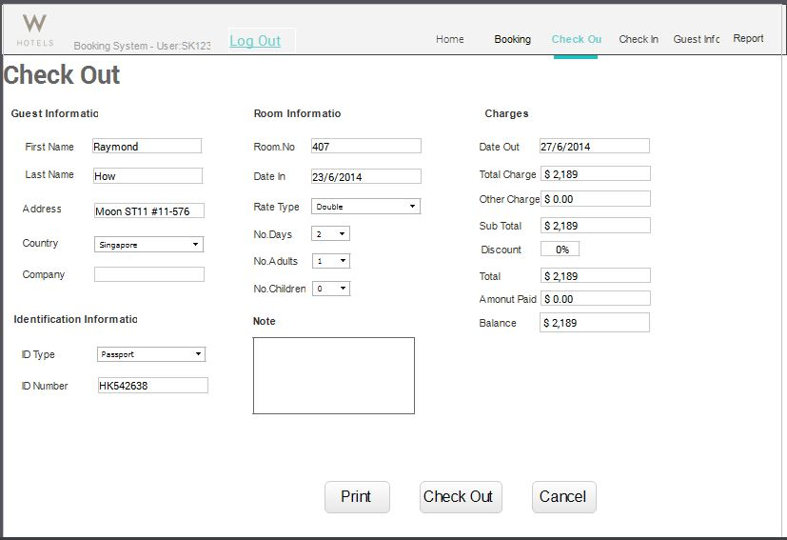

- Checkout – This interface will be what staff will see wen check out for user. In this page total balance and charge will be listed to allow guest procced to payment.

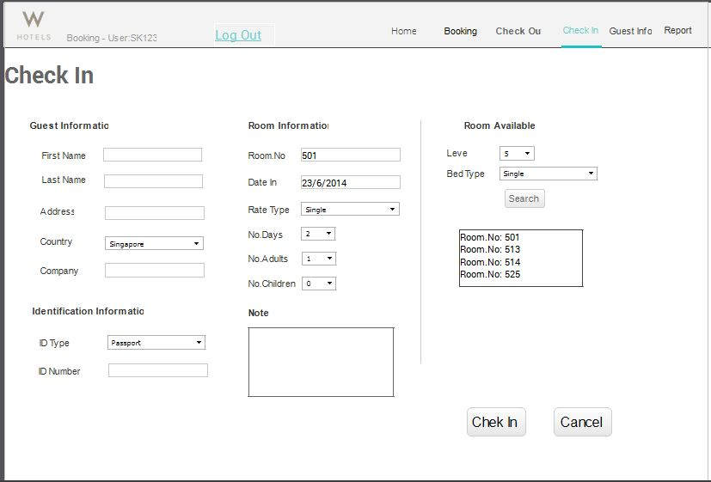
- Check in – Allow the staff to key in all the person detail for the guest.

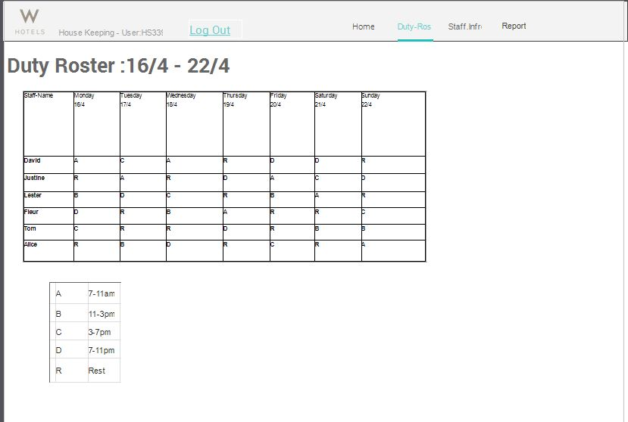
- Duty Roster- show the people on duty and the slot of their job

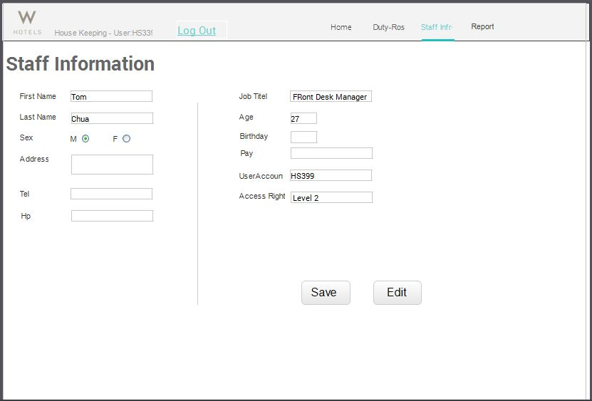
- Staff info- this page allow the staff to view and edit the staff information

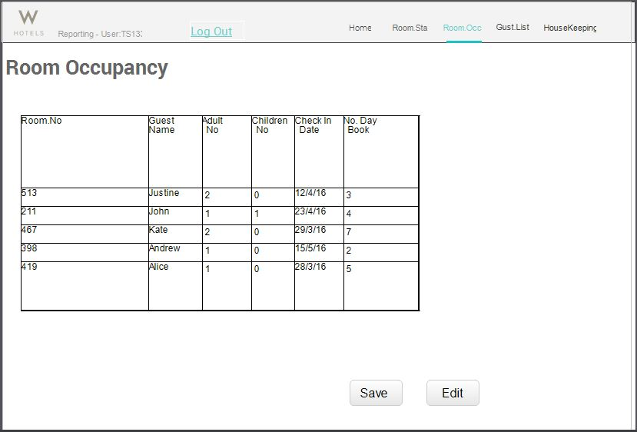
- Room occupancy – this report allows the management t to view the guest who stay on the hotel.

Interface with Other Systems

The developed system will be required to link up to the website. This will allow the guest to enquire about the status of the room directly from the hotel website. In order to implement this, the system and the website must be using a common database. For web security concerns, the hotel website must be using a https (Secure HTTP) connection. This is to ensure that the connection from the hotel website to the database is secure. The hotel website must also have a valid certificate. The developed system is a web based platform and should be able to work well with any web browser (eg. Google Chrome, Internet Explorer v7 and above, Mozilla firefox). All functions are required to work when tested with any web browser.

Assumptions

Assuming that the hotel has the required database server and networking devices such as router, switches and hardware firewall. The system can be deployed successfully without any teething issues. Training has provided on the usage of the system before the actual deployment.

OPERATIONAL AND QUALITY REQUIREMENTS

Operating Environment

The system will be installed on the receptionist PC which is running on a windows 7 operating system with intel core i5 processor, 4GB RAM and 500GB hard disk drive.

Development Constraints

The system only has a budget of $70000 and must be develop in 3 weeks.

Performance
Typically, different systems have different response time.

For room availability and booking, on average, the time taken for the system to respond should be around 2 seconds and it could take up to 2 minutes during peak hours. This is because, during peak hours is when most of the staffs are busy trying to help the guests to check out of the hotel and the system will be used for both the checking out of guests and checking the availability of rooms for new guests. Therefore, it will turn out slower during the peak hours.

For housekeeping and staff management, on average, the response time should be around 30 seconds. And maybe around a minute during the peak hours. the housekeeping module system would not be greatly affected by the peak hours, because it is only the administrators and the managers who are allowed to access the housekeeping module, and they do not need to deal with the guests unless necessary.

For reporting module, the response time would be about a minute in average, and can go up to 3-5 minutes during the peak hours. This is because, during the peak hours, the system is involved in a lot of things. Thus, it will be slow to respond as there are too much things going on.

Availability

As this system is used for hotel operation, it is required to run 24 hours. The acceptable downtime will be from 2am - 3am which is non-peak hours for data backup. It should be done only once a month.

Security and Access Control Requirements

The end-users consist of the managers, administrators and the receptionists. The normal users which is the receptionist is able to access the full features of the room management module and certain type of reports from the reporting module. The receptionist is not able to access the Housekeeping and Staff Management module. The manager account can access to all the 3 modules – Room management module, Housekeeping and staff management module and Reporting module. The administrator account will also have full access to all 3 modules and an additional user account management feature. This feature allows the administrator to create/delete or escalate the privilege of existing user account.

There would be a need to implement the web application security to the system. As web application security is a branch of information security that deals specifically with security of websites, web applications and web services; it would go well with our system it would protect the data from security threats. Security checkpoints and techniques could be enhanced at the early stages of the development as well as throughout the software development lifecycle.

The database should be encrypted to prevent third-parties from accessing the data. With this, all the guests’ sensitive information will be protected such as the guest personal particulars and credit card details.

Features Access Control table
Features | Receptionist | Manager | Administrator
Room Management | ✓ | ✓ | ✓
Check-in guest | ✓ | ✓ | ✓
Check out guest | ✓ | ✓ | ✓
View guest details | ✓ | ✓ | ✓
Assign room | ✓ | ✓ | ✓
View room status | ✓ | ✓ | ✓
Update guest particulars | ✓ | ✓ | ✓
Create new reservation | ✓ | ✓ | ✓
Amend reservation records | ✓ | ✓ | ✓
Delete reservation | ✓ | ✓ | ✓
House Keeping and Staff Management | ✗ | ✓ | ✓
View staff personal particulars | ✗ | ✓ | ✓
Assign duties to staff | ✗ | ✓ | ✓
View duties assigned | ✗ | ✓ | ✓
Delete assigned duties | ✗ | ✓ | ✓
Reporting Module | ✓ | ✓ | ✓
Room status report | ✓ | ✓ | ✓
Guest List report  (By Room) | ✓ | ✓ | ✓
All guest list report | ✓ | ✓ | ✓
Room occupancy report | ✗ | ✓ | ✓
Housekeeping report | ✗ | ✓ | ✓
User Account Creation | ✗ | ✗ | ✓

Fig 3.1 Features Access Control Table

SPECIAL REQUIREMENTS

The backup data are required to be kept in the system for a period of 5 years. The backup data should consist of the personal particulars of the guest and the hotel sales transaction. The computer that the system is being to deployed to must be able to access internet. Technical support for the system by the developer(vendor) must be available 24/7.

REFERENCES

http://www.slideshare.net/vidya_shankar/hotel-managementsystemcorrectfinalsrs

http://www.academia.edu/2112330/A_SAMPLE_HOTEL_MANAGEMENT_SY STEM_PROJECT_DOCUMENTATION

